ultramirinc.champs_mood.fragments

Class HomeFragment

java.lang.Object

android.support.v4.app.Fragment ultramirinc.champs_mood.fragments.HomeFragment

All Implemented Interfaces:

android.content.ComponentCallbacks, android.view.View.OnClickListener, android.view.View.OnCreateContextMenuListener, com.google.android.gms.common.api.GoogleApiClient.ConnectionCallbacks, com.google.android.gms.common.api.GoogleApiClient.OnConnectionFailedListener, com.google.android.gms.maps.GoogleMap.OnInfoWindowClickListener, com.google.android.gms.maps.OnMapReadyCallback, java.util.Observer



public class HomeFragment

extends android.support.v4.app.Fragment

implements java.util.Observer, com.google.android.gms.maps.OnMapReadyCallback, com.google.android.gms.common.api.GoogleApiClient.ConnectionC

Created by Etienne Berube on 2017­03­23. This class is the homepage of the app. When it is launched. It appears as the first tab the user will see. He will then see his current mood and the location of his friends on the map.

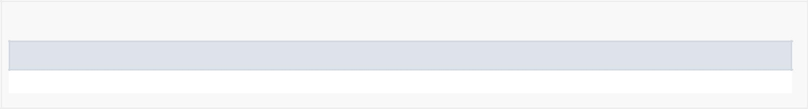

*Nested Class Summary*

Nested classes/interfaces inherited from class android.support.v4.app.Fragment

android.support.v4.app.Fragment.InstantiationException, android.support.v4.app.Fragment.SavedState

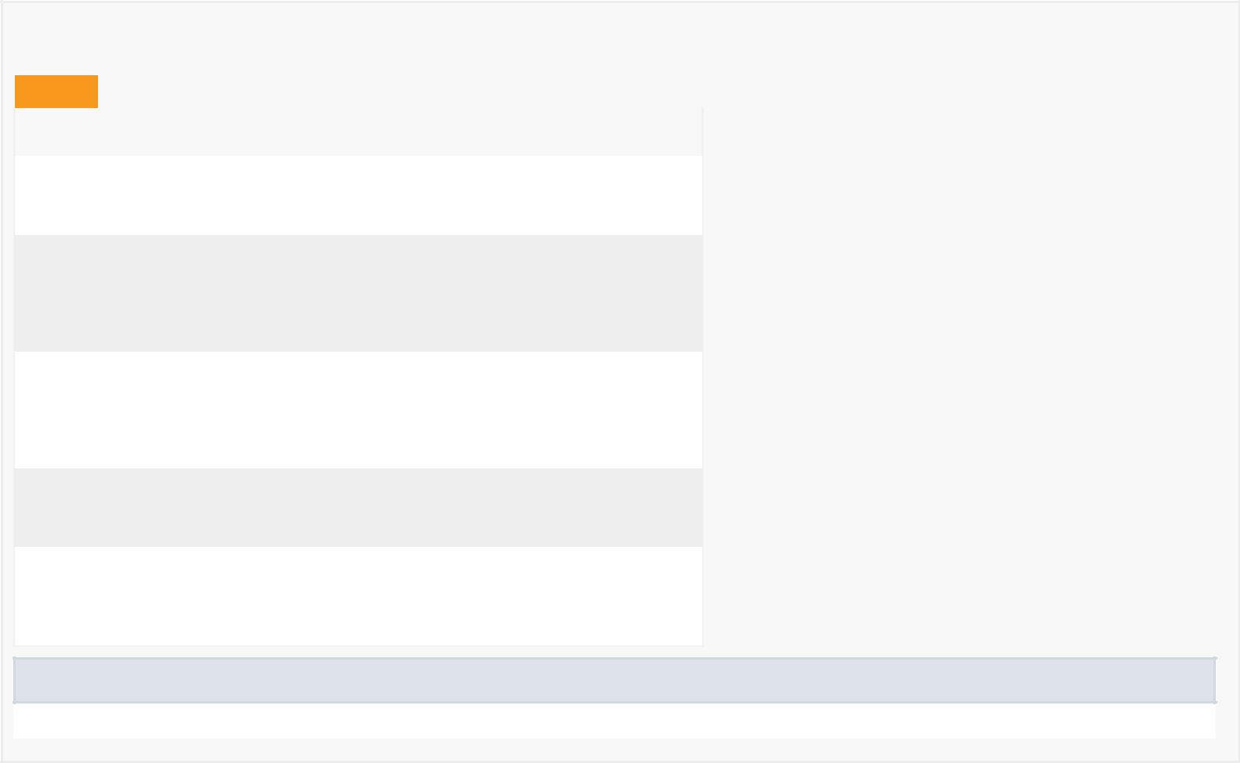

*Field Summary*

Fields

|  |  |
| --- | --- |
| Modifier and Type | Field and |
|  | Description |
| private java.util.List<User> | friends |
|  | Contains list of |
|  | the user's Friends |

private com.google.android.gms.common.api.GoogleApiClient mGoogleApiClient

The Google Api Client Object is required to access Google's APIs

private com.google.android.gms.location.LocationRequest mLocationRequest

The location request in order to get information from the GPS

private com.google.android.gms.maps.GoogleMap mMap

The map from

Google Map

private android.view.View view

Contains the visual layout of the fragment

Fields inherited from interface com.google.android.gms.common.api.GoogleApiClient.ConnectionCallbacks

CAUSE_NETWORK_LOST, CAUSE_SERVICE_DISCONNECTED

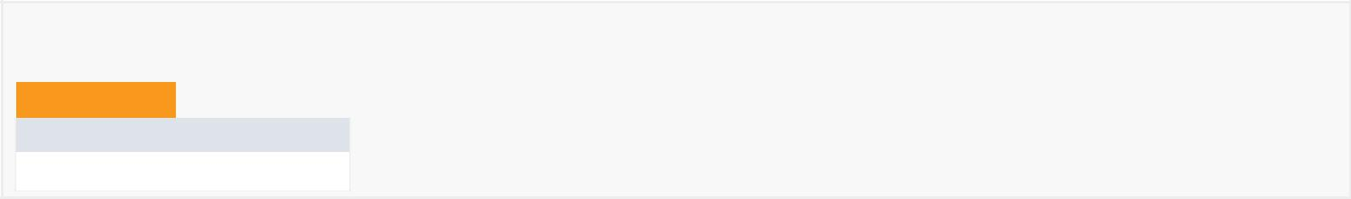

*Constructor Summary*

Constructors

Constructor and Description

HomeFragment()



*Method Summary*

|  |  |  |  |  |  |  |  |
| --- | --- | --- | --- | --- | --- | --- | --- |
|  | All Methods |  | [Instance Methods](javascript:show(2);) |  |  | [Concrete Methods](javascript:show(8);) |  |
|  | Modifier and Type | | Method and Description | | | | |
|  | private void | | createGoogleMapClient() | | | | |
|  |  |  | This method creates the Google Api Client used for the Google Map. | | | | |
|  |  |  |  |  |  | |  |
|  | private void | | createRequestLocation() | | | | |
|  |  |  | Creates the location requests in order to get the location from the user's phone | | | | |
|  | void | | drawMap() | | |  |  |
|  |  |  | Draws the map accordingly to the user's friends locations | | | | |
|  |  |  |  |  |  |  |  |
|  | void | | getFriends(User u) | | |  |  |
|  |  |  | Gets the current User's friends. | | | | |
|  | private void | | loadProfile() | | |  |  |
|  |  |  | Gets the current User's informations. | | | | |
|  |  |  |  |  |  | |  |
|  | void | | onClick(android.view.View v) | | | | |
|  | void | | onConnected(android.os.Bundle bundle) | | | | |
|  |  |  | This method is called when the Google Api Client is connected. | | | | |
|  |  |  |  |  |  | |  |
|  | void | | onConnectionFailed(com.google.android.gms.common.ConnectionResult connectionResult) | | | | |
|  | void | | onConnectionSuspended(int i) | | | | |
|  |  |  | This method is called when the connection between the Google Api Client and the user is lost. | | | | |
|  |  |  |  |  |  | |  |
|  | android.view.View onCreateView(android.view.LayoutInflater inflater, | | | | | | |
|  |  |  | android.view.ViewGroup container, android.os.Bundle savedInstanceState) | | | | |
|  |  |  | Inflates the visual layout for the fragment | | | | |
|  | void | | onDestroyView() | | |  |  |
|  |  |  |  |  |  | |  |
|  | void | | onInfoWindowClick(com.google.android.gms.maps.model.Marker marker) | | | | |
|  | void | | onMapReady(com.google.android.gms.maps.GoogleMap googleMap) | | | | |
|  |  |  |  |  |  |  |  |
|  | void | | onPause() | | |  |  |
|  | void | | onResume() | | |  |  |
|  |  |  |  |  |  | |  |
|  | void | | setDataListeners(User u) | | | | |
|  |  |  | Sets Listeners for the map to re­draw each time a friend changes its location. | | | | |
|  | void | | setUserAndPaintProfile(User u) | | | | |
|  |  |  | This method takes a User and sets the visual layout accordingly to certain fields and variables. | | | | |
|  |  |  |  |  |  | |  |
|  | void | | update(java.util.Observable o, java.lang.Object arg) | | | | |
|  | void | | updateView(User u) | | |  |  |
|  |  |  | Updates the View for the user's mood. | | | | |
|  |  |  |  |  |  |  |  |

Methods inherited from class android.support.v4.app.Fragment

dump, equals, getActivity, getAllowEnterTransitionOverlap, getAllowReturnTransitionOverlap, getArguments, getChildFragmentManager, getContext, getEnterTransition, getExitTransition, getFragmentManager, getHost, getId, getLayoutInflater, getLoaderManager, getParentFragment, getReenterTransition, getResources, getRetainInstance, getReturnTransition, getSharedElementEnterTransition, getSharedElementReturnTransition, getString, getString, getTag, getTargetFragment, getTargetRequestCode, getText, getUserVisibleHint, getView, hashCode, hasOptionsMenu, instantiate, instantiate, isAdded, isDetached, isHidden, isInLayout, isMenuVisible, isRemoving, isResumed, isVisible, onActivityCreated, onActivityResult, onAttach, onAttach, onAttachFragment, onConfigurationChanged, onContextItemSelected, onCreate, onCreateAnimation, onCreateContextMenu, onCreateOptionsMenu, onDestroy, onDestroyOptionsMenu, onDetach, onHiddenChanged, onInflate, onInflate, onLowMemory, onMultiWindowModeChanged, onOptionsItemSelected, onOptionsMenuClosed, onPictureInPictureModeChanged, onPrepareOptionsMenu, onRequestPermissionsResult, onSaveInstanceState, onStart, onStop, onViewCreated, onViewStateRestored, postponeEnterTransition, registerForContextMenu, requestPermissions, setAllowEnterTransitionOverlap, setAllowReturnTransitionOverlap, setArguments, setEnterSharedElementCallback, setEnterTransition, setExitSharedElementCallback, setExitTransition, setHasOptionsMenu, setInitialSavedState, setMenuVisibility, setReenterTransition, setRetainInstance, setReturnTransition, setSharedElementEnterTransition, setSharedElementReturnTransition, setTargetFragment, setUserVisibleHint, shouldShowRequestPermissionRationale, startActivity, startActivity, startActivityForResult, startActivityForResult, startIntentSenderForResult, startPostponedEnterTransition, toString, unregisterForContextMenu

Methods inherited from class java.lang.Object

clone, finalize, getClass, notify, notifyAll, wait, wait, wait

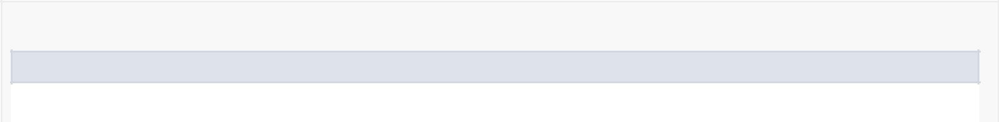

*Field Detail*

mMap

private com.google.android.gms.maps.GoogleMap mMap

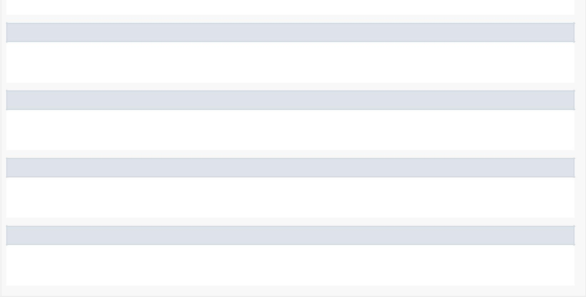The map from Google Map

mGoogleApiClient

private com.google.android.gms.common.api.GoogleApiClient mGoogleApiClient

The Google Api Client Object is required to access Google's APIs

view

private android.view.View view

Contains the visual layout of the fragment

mLocationRequest

private com.google.android.gms.location.LocationRequest mLocationRequest

The location request in order to get information from the GPS

friends

private java.util.List<User> friends

Contains list of the user's Friends

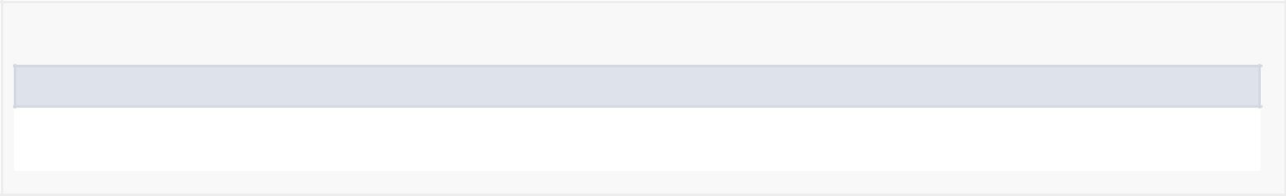

*Constructor Detail*

HomeFragment

public HomeFragment()

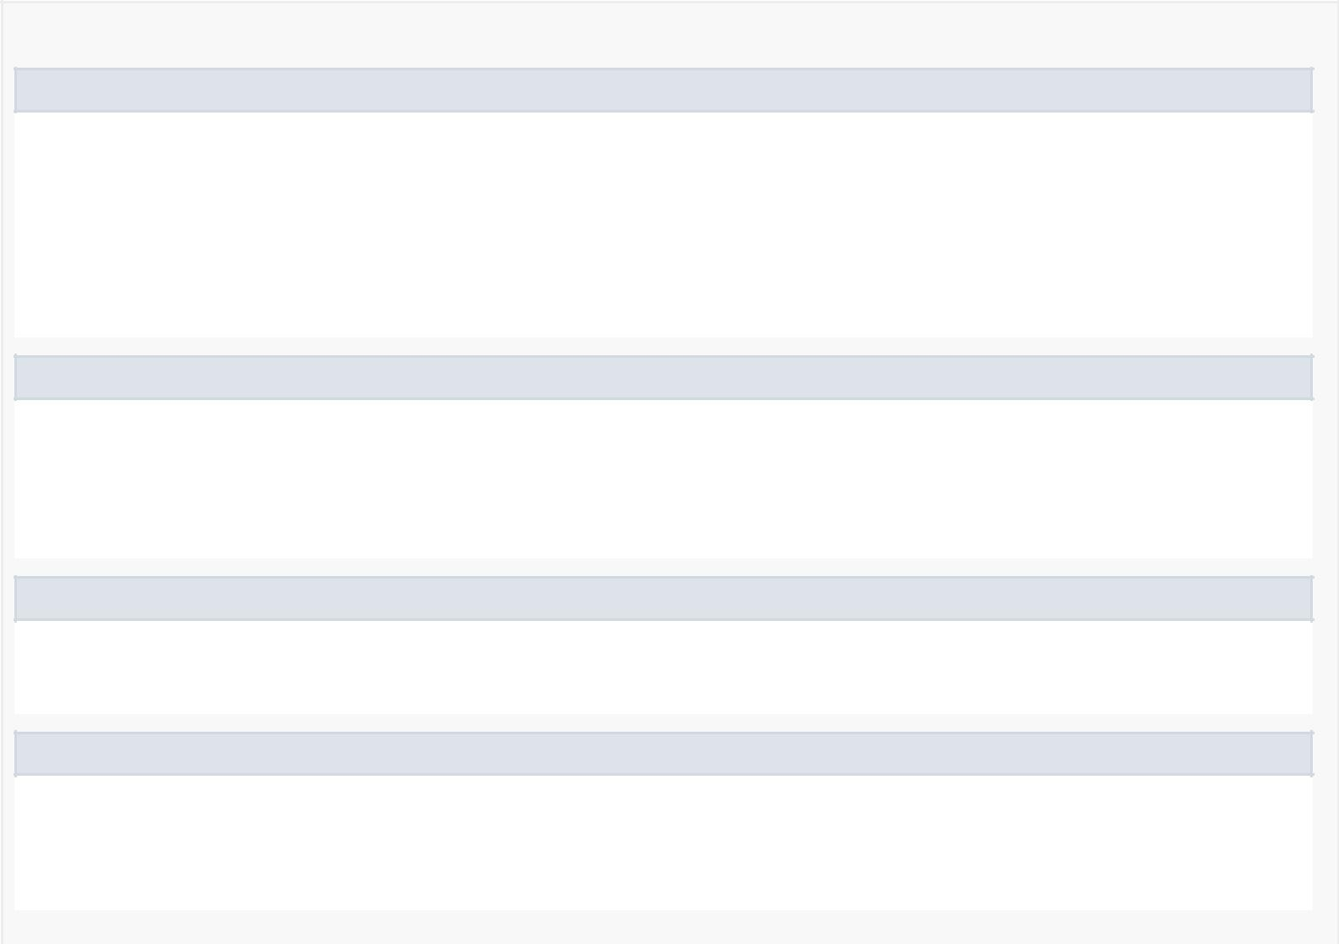

*Method Detail*

onCreateView

public android.view.View onCreateView(android.view.LayoutInflater inflater, android.view.ViewGroup container, android.os.Bundle savedInstanceState)

Inflates the visual layout for the fragment

Overrides:

onCreateView in class android.support.v4.app.Fragment

update

public void update(java.util.Observable o, java.lang.Object arg)

Specified by:

update in interface java.util.Observer

updateView

public void updateView(User u)

Updates the View for the user's mood.

onResume

public void onResume()

Overrides:

onResume in class android.support.v4.app.Fragment

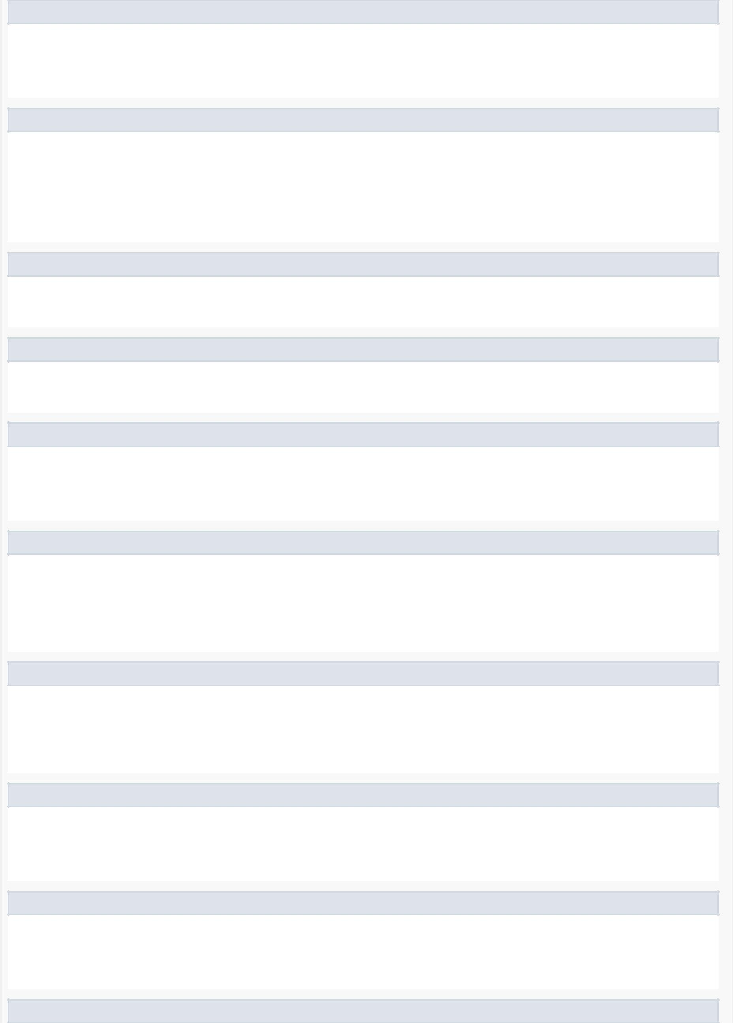onPause

public void onPause()

Overrides:

onPause in class android.support.v4.app.Fragment

onConnected

public void onConnected(@Nullable android.os.Bundle bundle)

This method is called when the Google Api Client is connected.

Specified by:

onConnected in interface com.google.android.gms.common.api.GoogleApiClient.ConnectionCallbacks

createGoogleMapClient

private void createGoogleMapClient()

This method creates the Google Api Client used for the Google Map.

createRequestLocation

private void createRequestLocation()

Creates the location requests in order to get the location from the user's phone

onMapReady

public void onMapReady(com.google.android.gms.maps.GoogleMap googleMap)

Specified by:

onMapReady in interface com.google.android.gms.maps.OnMapReadyCallback

onConnectionSuspended

public void onConnectionSuspended(int i)

This method is called when the connection between the Google Api Client and the user is lost.

Specified by:

onConnectionSuspended in interface com.google.android.gms.common.api.GoogleApiClient.ConnectionCallbacks

onConnectionFailed

public void onConnectionFailed(@NonNull

com.google.android.gms.common.ConnectionResult connectionResult)

Specified by:

onConnectionFailed in interface com.google.android.gms.common.api.GoogleApiClient.OnConnectionFailedListener

onDestroyView

public void onDestroyView()

Overrides:

onDestroyView in class android.support.v4.app.Fragment

onClick

public void onClick(android.view.View v)

Specified by:

onClick in interface android.view.View.OnClickListener

setUserAndPaintProfile

public void setUserAndPaintProfile(User u)

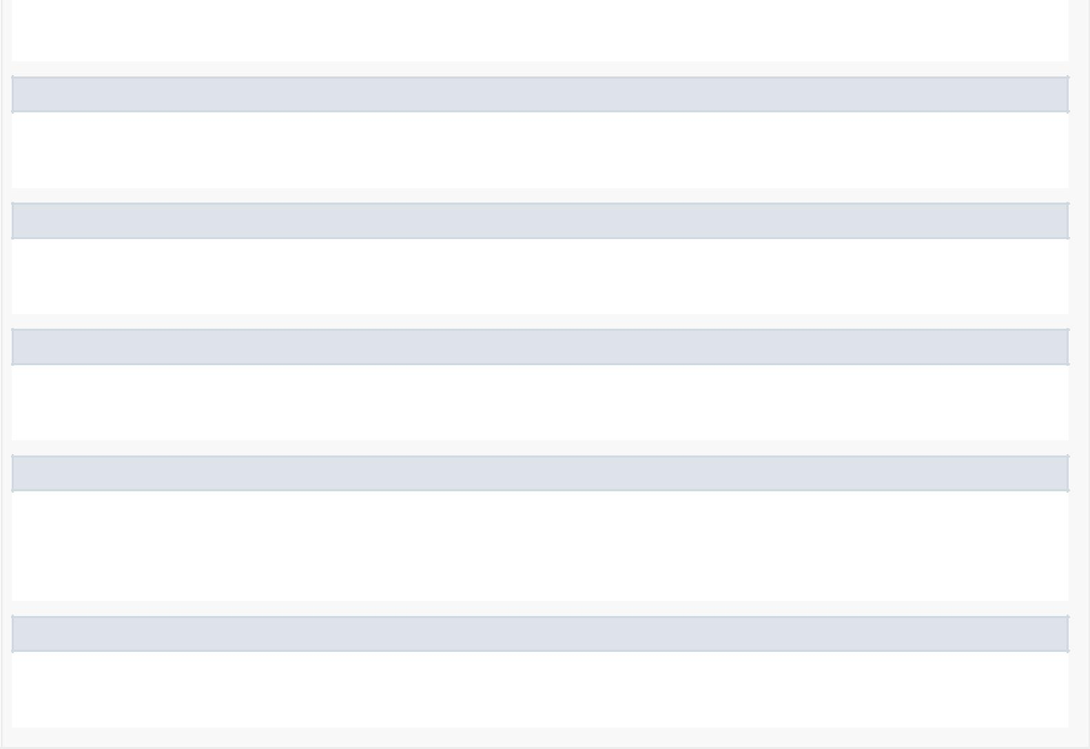

This method takes a User and sets the visual layout accordingly to certain fields and variables.

loadProfile

private void loadProfile()

Gets the current User's informations.

getFriends

public void getFriends(User u)

Gets the current User's friends.

setDataListeners

public void setDataListeners(User u)

Sets Listeners for the map to re­draw each time a friend changes its location.

onInfoWindowClick

public void onInfoWindowClick(com.google.android.gms.maps.model.Marker marker)

Specified by:

onInfoWindowClick in interface com.google.android.gms.maps.GoogleMap.OnInfoWindowClickListener

drawMap

public void drawMap()

Draws the map accordingly to the user's friends locations